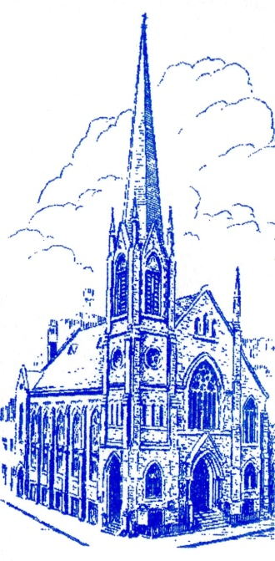
Immanuel Lutheran Church
122 East 88th Street, New York, NY 10128

212-289-8128
www.immanuelnyc.org
www.facebook.com/ImmanuelLutheranChurchNYC

Immanuel’s YouTube Channel:
https://www.youtube.com/channel/UC1xDAacoJS7umLnd1Bnugmw
You can tune in at 11 a.m. or later in the day for a recording.

First Sunday of Advent
11 a.m., Sunday, November 28, 2021

W
arm welcome, everyone, to Immanuel Lutheran Church.
This is the First Sunday of Advent. We have in place our blue paraments and our Advent/Christmas banner, with the trumpets blowing above and below.
Most Sundays, we live stream our morning liturgy. We plan to do so this morning too. If for some reason, the live stream does not work this morning, you should be able to watch the recorded service later in the day. Actually you can always do that, whether you watch at 11 a.m. or not.
Our Task Force on Re-Opening says that if we are vaccinated then masks are optional. But if we are not vaccinated, then we should wear masks. Also the Task Force says that we can sing again!
Carol and I are fully vaccinated, but at least for a while, we mean to wear our masks when we are close to the people, as in the Distribution of Holy Communion.
We hope you will find strength for your souls in this liturgy. Thank you for joining in the prayers of thanksgiving by way of the Lord’s Supper.

If you do not already have a church home, please consider joining us here at Immanuel. Just speak with Pastor Carol or send her a note (ceafryer@gmail.com).
In Christ,
Pastor Gregory P. Fryer
gpfryer@gmail.com

Lutheran Book of Worship, Setting Three

PRELUDE Nun komm der Heiden Heiland
Johann Sebastian Bach (1685-1750)

THE BELLS

Please stand when the minister approaches the center aisle.

Brief Order for Confession and Forgiveness
P In the name of the Father, and of the + Son, and of the Holy Spirit.
C Amen.

P Almighty God, to whom all hearts are open, all desires known, and from whom no secrets are hid: Cleanse the thoughts of our hearts by the inspiration of your Holy Spirit, that we may perfectly love you and worthily magnify your holy name,
through Jesus Christ our Lord.
C Amen.

P If we say we have no sin, we deceive ourselves, and the truth is not in us. But if we confess our sins, God who is faithful and just will forgive our sins and cleanse us from all unrighteousness.

Stand/kneel

P Most merciful God,
C we confess that we are in bondage to sin and cannot free ourselves. We have sinned against you in thought, word, and deed, by what we have done and by what we have left undone. We have not loved you with our whole heart; we have not loved our neighbors as ourselves. For the sake of your Son, Jesus Christ, have mercy on us. Forgive us, renew us, and lead us, so that we may delight in your will and walk in your ways, to the glory of your holy name. Amen.

The minister stands and addresses the congregation.

P Almighty God, in his mercy, has given his Son to die for us and, for his sake, forgives us all our sins. As a called and ordained minister of the Church of Christ, and by his authority, I therefore declare to you the entire forgiveness of all your sins, in the name of the Father, and the + Son, and of the Holy Spirit. Amen.

The Entrance Rite

HYMN LBW 321 The Day Is Surely Drawing Near es ist gewisslich

1 The day is surely drawing near
when Jesus, God’s anointed,
in all his power shall appear
as judge whom God appointed.
Then fright shall banish idle mirth,
and hungry flames shall ravage earth,
as scripture long has warned us.

2 The final trumpet then shall sound,
and all the earth be shaken,
and all who rest beneath the ground
shall from their sleep awaken.
But all who live will in that hour,
by God’s almighty, boundless pow’r,
be changed at his commanding.

3 May Christ our intercessor be
and, through this blood and merit,
read from his book that we are free
with all who life inherit.
Then we shall see him face to face,
with all his saints in that blest place
which he has purchased for us.

4 O Jesus Christ, do not delay,
but hasten our salvation;
we often tremble on our way
in fear and tribulation.
Oh, hear and grant our fervent plea;
come, mighty judge, and set us free
from death and ev’ry evil.

Text: Bartholomäus Ringwaldt, 1532-c. 1600; tr. Philip A. Peter, 1832-1917, adapt.

APOSTOLIC GREETING
P The grace of our Lord Jesus Christ, the love of God, and the communion of the Holy Spirit be with you all.
C And also with you.

Kyrie
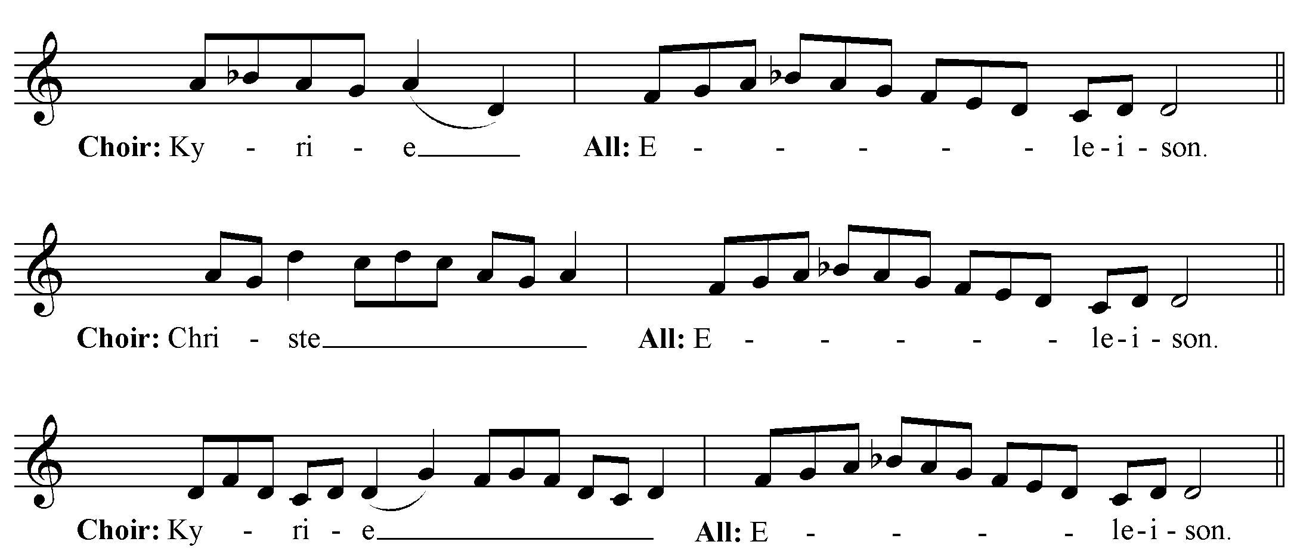

PRAYER OF THE DAY
P The Lord be with you.
C And also with you.

P Stir up your power, O Lord, and come. Protect us by your strength and save us from the threatening dangers of our sins, for you live and reign with the Father and the Holy Spirit, one God, now and forever. Amen

ADVENT CANDLE (The first candle is lit by Karel Horky)
P We praise you, O God, with this evergreen crown that marks our days of preparation for Christ’s advent. As we light the first candle on this wreath, rouse us from sleep that we may be ready to greet our Lord when he comes with all the saints and angels. Enlighten us with your grace and prepare our hearts to welcome him with joy. Grant this through Christ our Lord whose coming is certain and whose day draws near. Amen.

Sit

The Liturgy of the Word of God

First Lesson Jeremiah 33:14-16, RSV
In the Old Testament, “righteousness” is about being faithful in relationship. The LORD acts righteously both in punishing Israel for its sin and in having mercy. In today’s reading, Jerusalem’s future name—“The Lord is our righteousness”—proclaims that the LORD is even now working salvation for Israel.

¹⁴Behold, the days are coming, says the LORD, when I will fulfil the promise I made to the house of Israel and the house of Judah. ¹⁵In those days and at that time I will cause a righteous Branch to spring forth for David; and he shall execute justice and righteousness in the land. ¹⁶In those days Judah will be saved and Jerusalem will dwell securely. And this is the name by which it will be called: “The LORD is our righteousness.”

A The word of the Lord. C Thanks be to God.

Psalm 25:1-9, LBW

Choir ¹To you, O Lord, I lift up my soul; my God, I put my / trust in you;*
let me not be humiliated, nor let my enemies triumph / over me.
All ²Let none who look to you be / put to shame;*
let the treacherous be disappointed / in their schemes.
Choir ³Show me your / ways, O Lord,*
and teach / me your paths.
All ⁴Lead me in your / truth and teach me,*
for you are the God of my salvation;
in you have I trusted all / the day long.
Choir ⁵Remember, O Lord, your compas- / sion and love,*
for they are from / everlasting.
All ⁶Remember not the sins of my youth and / my transgressions;*
remember me according to your love
and for the sake of your good- / ness, O Lord.
Choir ⁷Gracious and upright / is the Lord;*
therefore he teaches sinners / in his way.
All ⁸He guides the humble in / doing right*
and teaches his way / to the lowly.
⁹All the paths of the Lord are / love and faithfulness*
to those who keep his covenant and his / testimonies.
Second Lesson 1 Thessalonians 3:9-13, NRSV
Upon Timothy’s report from the congregation at Thessalonica, Paul is exuberant with gratitude for them. In this passage from his letter, Saint Paul voices overflowing thanks, joy, and blessings for the people of this growing church.

⁹How can we thank God enough for you in return for all the joy that we feel before our God because of you? ¹⁰Night and day we pray most earnestly that we may see you face to face and restore whatever is lacking in your faith.
¹¹Now may our God and Father himself and our Lord Jesus direct our way to you. ¹²And may the Lord make you increase and abound in love for one another and for all, just as we abound in love for you. ¹³And may he so strengthen your hearts in holiness that you may be blameless before our God and Father at the coming of our Lord Jesus with all his saints.

A The word of the Lord. C Thanks be to God.

Please stand for the singing of the Gospel Acclamation and for the reading of the Holy Gospel.

ALLELUIA: Traditional Gregorian Chant
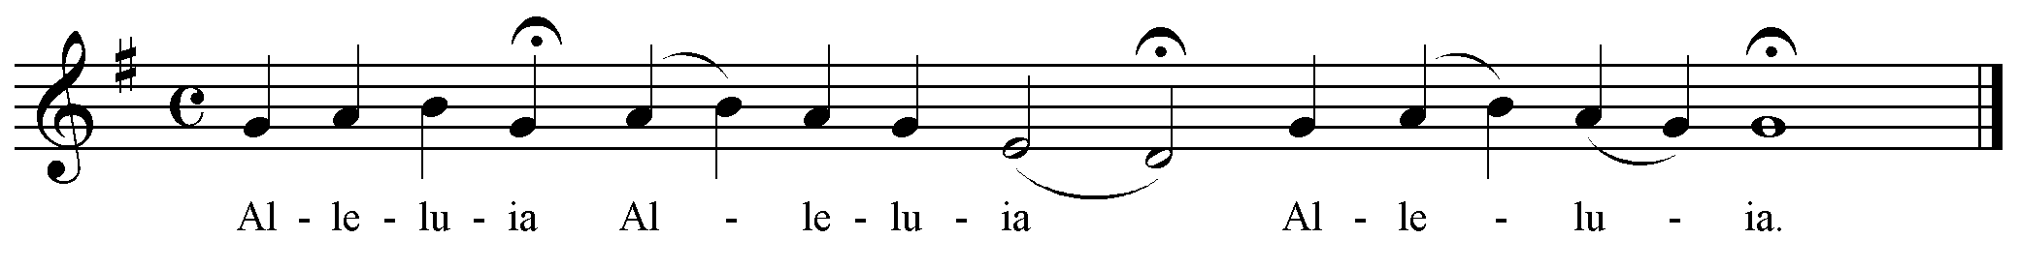
All: Alleluia.
Verse (Choir): Show us your steadfast love, O Lord,
and grant us your salvation.
All: Alleluia.

Holy Gospel Luke 21:25-36, RSV
Before the Gospel:
P The Holy Gospel according to St. Luke, the twenty-first chapter:
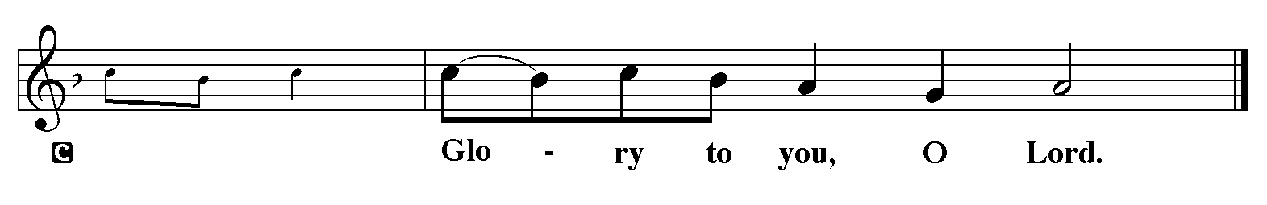

[Jesus said to his disciples:] And there will be signs in sun and moon and stars, and upon the earth distress of nations in perplexity at the roaring of the sea and the waves, ²⁶men fainting with fear and with foreboding of what is coming on the world; for the powers of the heavens will be shaken. ²⁷And then they will see the Son of man coming in a cloud with power and great glory. ²⁸Now when these things begin to take place, look up and raise your heads, because your redemption is drawing near.”
²⁹And he told them a parable: “Look at the fig tree, and all the trees; ³⁰as soon as they come out in leaf, you see for yourselves and know that the summer is already near. ³¹So also, when you see these things taking place, you know that the kingdom of God is near. ³²Truly, I say to you, this generation will not pass away till all has taken place. ³³Heaven and earth will pass away, but my words will not pass away.
³⁴“But take heed to yourselves lest your hearts be weighed down with dissipation and drunkenness and cares of this life, and that day come upon you suddenly like a snare; ³⁵for it will come upon all who dwell upon the face of the whole earth. ³⁶But watch at all times, praying that you may have strength to escape all these things that will take place, and to stand before the Son of man.”

After the Gospel:
P The Gospel of the Lord!
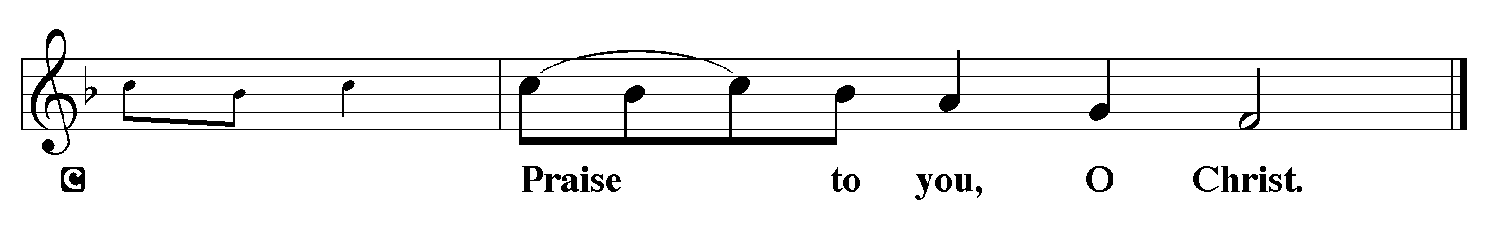

HYMN LBW 38 O Savior, Rend the Heavens Wide
o heiland, reiss die himmel auf

1 O Savior, rend the heavens wide;
Come down, come down with mighty stride;
Unlock the gates, the doors break down;
Unbar the way to heaven’s crown.

2 O Morning Star, O radiant Sun,
When will our hearts behold your dawn?
O Sun, arise; without your- light
We grope in gloom and dark of night.

3 Sin’s dreadful doom upon us lies;
Grim death looms fierce before our eyes.
Oh, come, lead us with mighty hand
From exile to our promised land.

4 There shall we all our praises bring
Ever to you, our Savior King;
There shall we laud you and adore
Forever and forever more.

Text: German spiritual song, Köln, 1623; tr. Mar

SERMON

Following the sermon, silence for reflection. Then stand for the Creed.

APOSTLES’ CREED
C I believe in God, the Father almighty, creator of heaven and earth.

I believe in Jesus Christ, his only Son, our Lord. He was conceived by the power of the Holy Spirit and born of the virgin Mary. He suffered under Pontius Pilate, was crucified, died, and was buried. He descended into hell. On the third day he rose again. He ascended into heaven, and is seated at the right hand of the Father. He will come again to judge the living and the dead.

I believe in the Holy Spirit, the holy catholic Church, the communion of saints, the forgiveness of sins, the resurrection of the body, and the life everlasting. Amen.

intercessions

The Liturgy of the Eucharistic Meal

The Peace
P The peace of the Lord be with you always.
C And also with you.
Let us offer a sign of peace to our neighbors: “Peace be with you.”

The Offering You can give your tithes and offerings via our Q code. Just point the camera on your smart phone to this code on your screen:

Or you can donate via this link: Donate Here are some other options for giving: Ways to Give

The Eucharistic Bread and Wine are moved from the credence table to the altar. The congregation remains in the pews until the Distribution of the Sacrament.

Anthem Rorate Coeli Joseph Rheinberger (1839 – 1901)

Rorate caeli desuper
et nubes pluant iustum.
Aperiatur terra
et germinet salvatorem.
Drop down, ye heavens, from above,
and let the skies pour down righteousness:
let the earth open,
and let it bring forth a Saviour.

A Let us pray.
C Merciful Father, we offer with joy and thanksgiving what you have first given us—our selves, our time, and our possessions, signs of your gracious love. Receive them for the sake of him who offered himself for us, Jesus Christ our Lord. Amen.

The Great Thanksgiving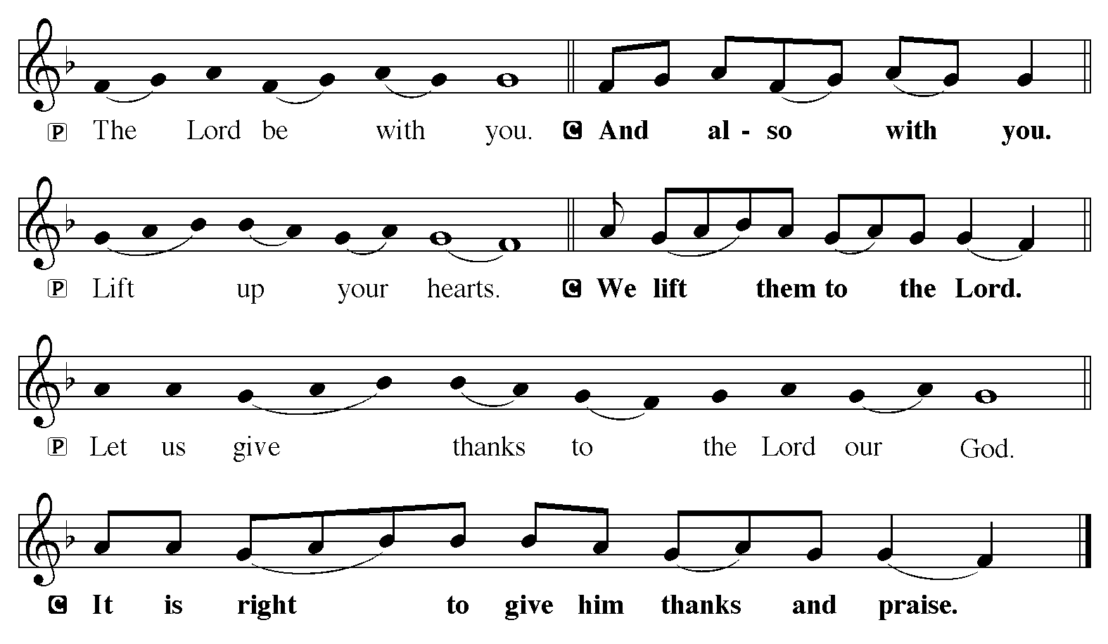

Preface for Advent
P It is indeed right and salutary that we should at all times and in all places offer thanks and praise to you, O Lord, holy Father, almighty and ever-living God. You comforted your people with the promise of the Redeemer, through whom you will also make all things new in the day when he comes again to judge the world in righteousness. And so, with the Church on earth and the hosts of heaven, we praise your name and join their unending hymn:

Sanctus
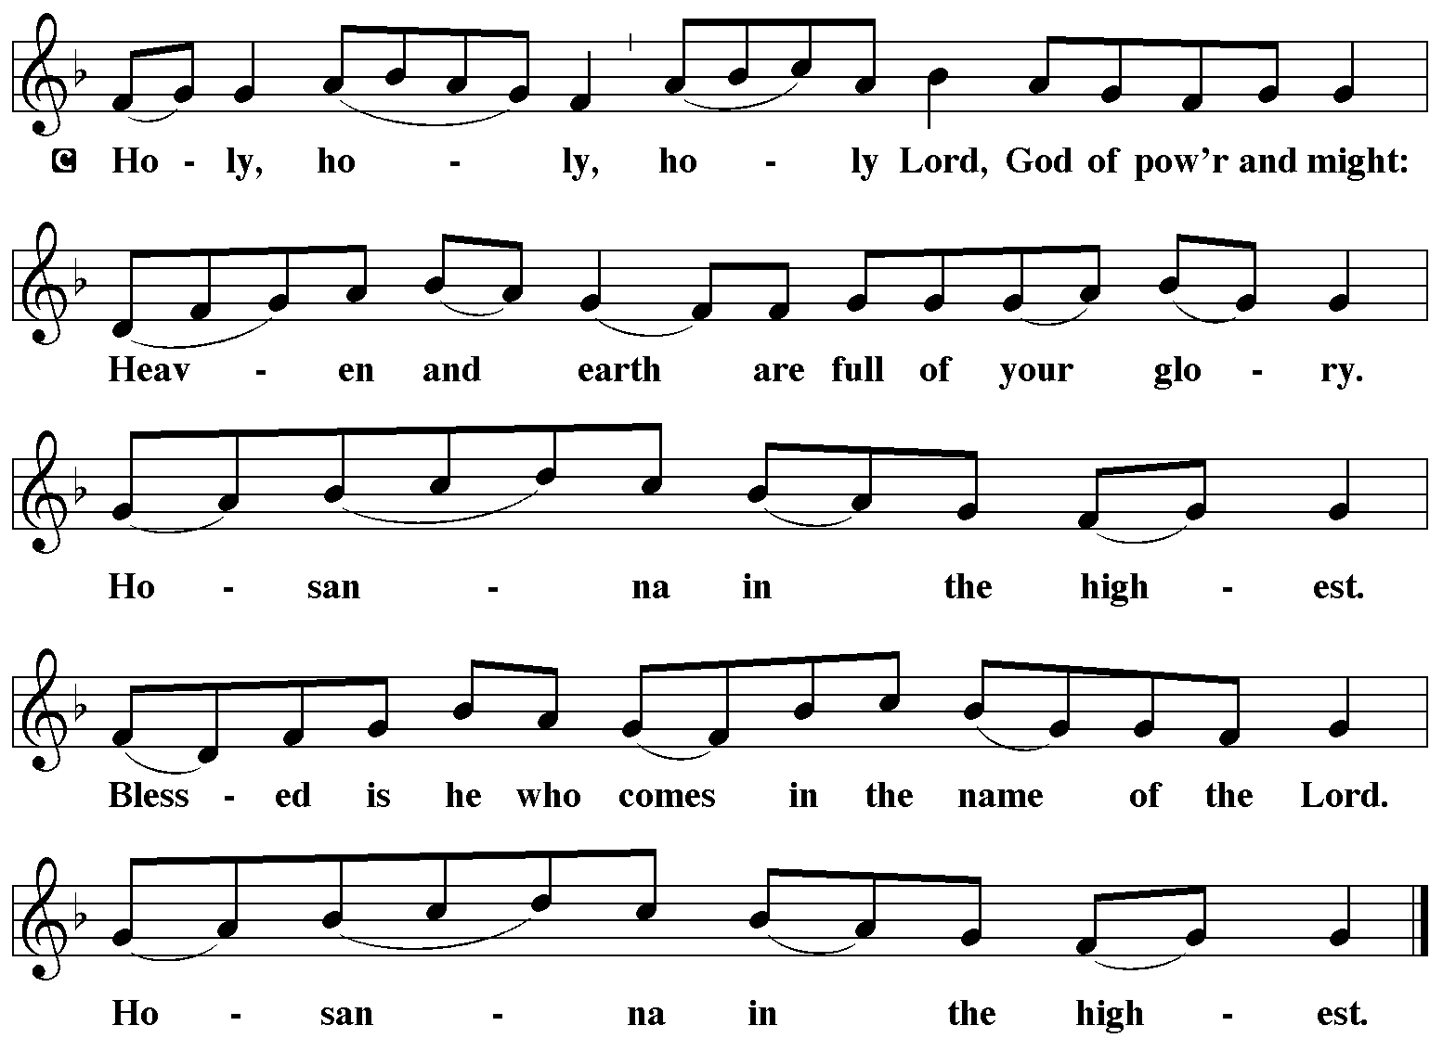

Eucharistic Prayer I
P Holy God, mighty Lord, gracious Father: Endless is your mercy and eternal your reign. You have filled all creation with light and life; heaven and earth are full of your glory. Through Abraham you promised to bless all nations. You rescued Israel, your chosen people. Through the prophets you renewed your promise; and, at this end of all the ages, you sent your Son, who in words and deeds proclaimed your kingdom and was obedient to your will, even to giving his life.

In the night in which he was betrayed, our Lord Jesus took bread, and gave thanks; broke it, and gave it to his disciples, saying: Take and eat; this is my body, given for you. Do this for the remembrance of me.

Again, after supper, he took the cup, gave thanks, and gave it for all to drink, saying: This cup is the new covenant in my blood, shed for you and for all people for the forgiveness of sin. Do this for the remembrance of me.

For as often as we eat of this bread and drink from this cup we proclaim the Lord’s death until he comes.

C Christ has died. Christ is risen. Christ will come again.

P Therefore, gracious Father, with this bread and cup we remember the life our Lord offered for us. And, believing the witness of his resurrection, we await his coming in power to share with us the great and promised feast.

C Amen. Come, Lord Jesus.

P Send now, we pray, your Holy Spirit, the spirit of our Lord and of his resurrection, that we who receive the Lord’s body and blood may live to the praise of your glory and receive our inheritance with all your saints in light.

C Amen. Come, Holy Spirit.

P Join our prayers with those of your servants of every time and every place, and unite them with the ceaseless petitions of our great high priest until he comes as victorious Lord of all.

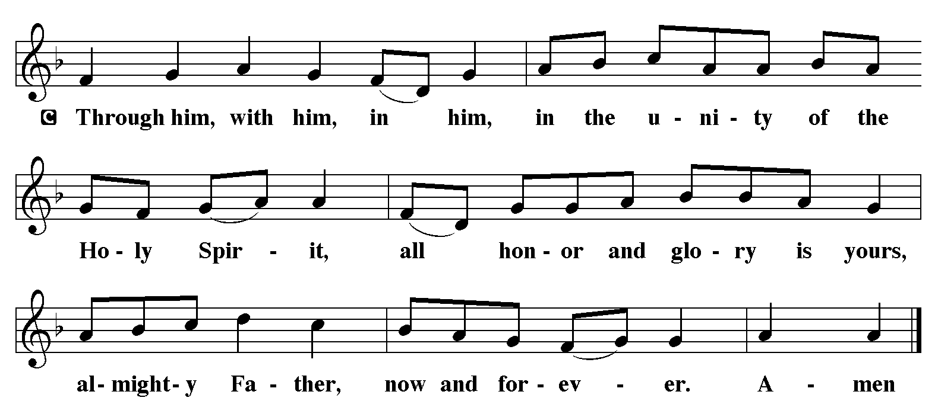

The Lord’s Prayer
C Our Father, who art in heaven, hallowed be thy name, thy kingdom come, thy will be done, on earth as it is in heaven. Give us this day our daily bread; and forgive us our trespasses, as we forgive those who trespass against us; and lead us not into temptation, but deliver us from evil. For thine is the kingdom, and the power, and the glory, forever and ever. Amen.

The Fraction. (The host is broken.)

Agnus Dei
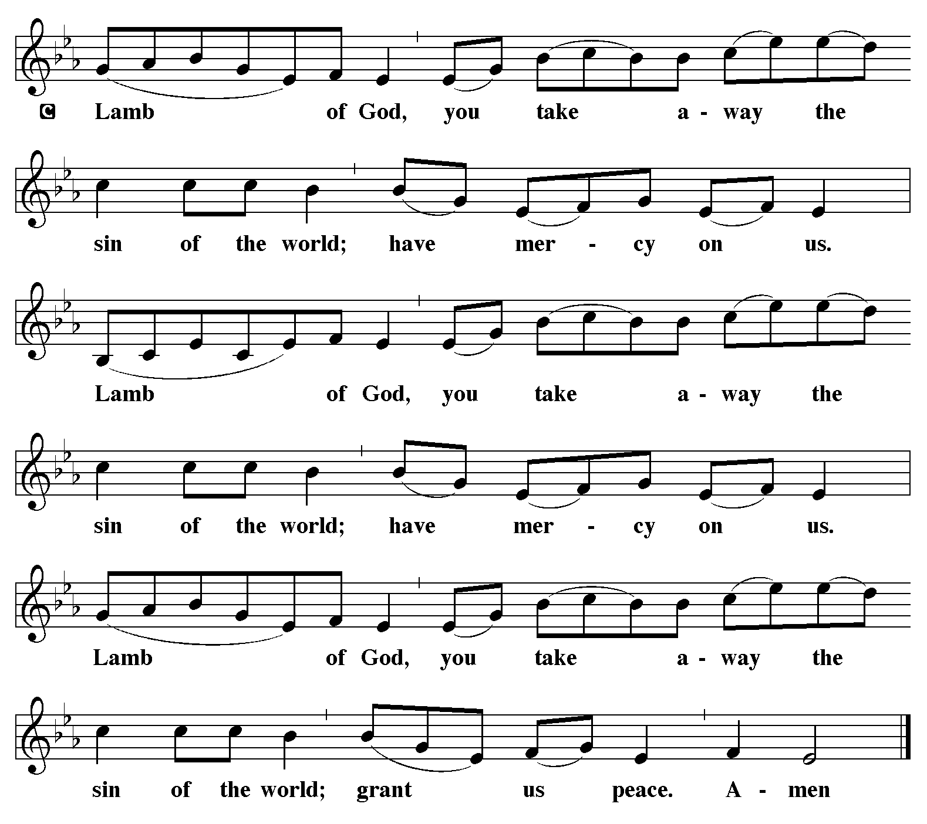

Sit

The Distribution of the Sacrament
- If you are home during this pandemic, worshiping online with us, here is a possible “Prayer for Spiritual Communion” lifted up in Forum Letter (May 2020). Forum Letter is a respected Lutheran newsletter published by the American Lutheran Publicity Bureau:

My Jesus, I believe that You are present in the Most Holy Sacrament. I love You above all things, and I desire to receive You into my soul. Since I cannot at this moment receive You sacramentally, come at least spiritually into my heart. I embrace You as if You were already there and unite myself wholly to You. Never permit me to be separated from You. Amen.

Communion Anthem Dearest Lord Jesus Johann Sebastian Bach (1685-1750)

Dearest Lord Jesu, oh why dost Thou tarry?
Come now for I am of waiting so weary,
Come now and comfort my heart in despair;
Take me from misery, sorrow and care.
Come now, Lord Jesu,
Oh why dost Thou tarry? oh why dost Thou tarry?
Come now for I am of waiting so weary, so weary.

Deck Thee, oh deck thee, meet garment prepare Thee
Keep thy lamp burning, and oil ever near three,
Ready, oh faithful one, fit for the Feast
At midnight call for thee, oh wedding guest.
Come now, Lord Jesu,
Oh why dost Thou tarry? oh why dost Thou tarry?
Come now for I am of waiting so weary, so weary.

Communion Meditation Ricercar in C minor Johann Pachelbel (1653-1706)

Hymn LBW 33 The King Shall Come consolation

1 The King shall come when morning dawns
and light triumphant breaks,
when beauty gilds the eastern hills
and life to joy awakes.

2 Not as of old a little child,
to bear and fight and die,
but crowned with glory like the sun
that lights the morning sky.

3 Oh, brighter than the rising morn
when Christ, victorious, rose
and left the lonesome place of death,
despite the rage of foes.

4 Oh, brighter than that glorious morn
shall dawn upon our race
the day when Christ in splendor comes,
and we shall see his face.

5 The King shall come when morning dawns
and light and beauty brings.
Hail, Christ the Lord! Your people pray:
come quickly, King of kings.

Text: John Brownlie, 1859-1925

When all have received the Blessed Sacrament, the people stand for the Post-Communion Blessing:

P The body and blood of our Lord Jesus Christ strengthen you and keep you in his grace.
C Amen

Post-Communion Prayer

The Sending

BENEDICTION (Spoken)

HYMN LBW 37 Hark A Thrilling Voice freilen wir uns all in ein

1 Hark! A thrilling voice is sounding!
“Christ is near,” we hear the cry.
“Cast away the works of darkness,
all you children of the day!”

2 Startled at the solemn warning,
let the earthbound soul arise;
Christ, its sun, all sloth dispelling,
shines upon the morning skies.

3 See the Lamb, so long expected,
comes with pardon down from heav’n.
Let us haste, with tears of sorrow,
one and all, to be forgiv’n;

4 So, when next he comes in glory
and the world is wrapped in fear,
he will shield us with his mercy
and with words of love draw near.

5 Honor, glory, might, dominion
to the Father and the Son
with the everliving Spirit
while eternal ages run!

Text: Latin hymn, 1632; tr. Edward Caswall, 1814-1878, alt.

DISMISSAL
A Go in peace. Serve the Lord.
C Thanks be to God.

POSTLUDE Nun Komm der Heiden Heiland Johann Pachelbel (1653-1706)

Parish Announcements

- COFFEE HOUR IN THE UNDERCROFT. Please join us for refreshments and fellowship following the Liturgy. To get to the undercroft for Coffee Hour, bear to the left in the narthex as you would exit the church.
- ABOUT TODAY’S PARAMENTS AND VESTMENTS. The blue paraments and vestments used during Advent are symbolic of hope. We hope for the Christ child to be born in us, and we wait in hope for his return.
- The ADVENT BANNER. Two trumpets are shown – one descending to announce the coming Christ and one ascending in praise for grace and thanksgiving for the coming Kingdom.
- HANGING OF THE GREENS. We will decorate the sanctuary for Christmas on Saturday afternoon, December 18th, from 2 to 5 p.m.
- OUR ST. NICHOLAS PARTY will take place on December 18th from 5 to 9 p.m., with live music, festive hams and your pot luck dishes! Let Barbara Chomko know what you can bring, or use the sign-up sheet downstairs. Welcome! To comply with NYC vaccination mandates, this party is for folks who have been vaccinated.
- CHRISTMAS POINSETTIA AND MUSIC FUND. The church is decorated at Christmas with a lighted tree and poinsettias. Members and friends may wish to place one or more poinsettia plants in the church to honor the memory of departed loved ones or simply as a gift to the glory of God in the incarnate Christ. A gift of $20.00 for each plant as well as gifts toward the Christmas Music Fund may be given, using the envelope included with this bulletin for your convenience. You may place it in the offering plate or give it to Ester Neubacher or Pastor Carol after church today, and again on December 5th and 12th.
- TOY COLLECTION: The Sisters of the Fraternité Notre Dame will again be hosting a Christmas party for needy children. They are asking for donations of new toys. If you can give a toy, please wrap it and mark it as to the age of the child and whether it is for a boy or girl. (Please no guns or violent toys.) You may leave your gifts in the narthex on Sunday mornings, or bring them to the church office during the week. Let’s aim for Sunday December 12 as the last Sunday for bringing gifts.
- CHRISTMAS MITTEN TREE. The Sunday School will have a mitten tree once again this year. Please give the mittens (or gloves) you bring to one of our Sunday School teachers. The mittens will be given to the Fraternité Notre Dame who will distribute them to needy children. The mitten tree will be put up during the Hanging of the Greens on December 18th.
- Join us for COMPLINE (Prayer at the Close of the Day) this evening at 8 pm via Zoom or in Pastor Carol’s study, 120 East 88th, Apt 1F; and MIDWEEK HOLY COMMUNION at 6:30 pm.
- COPYRIGHTS: Parts of the liturgy and scripture introductions come from or are based on those from Sundays and Seasons, Copyright © 2021 Augsburg Fortress, license SAS022429. Readings of Holy Scripture are downloaded from Bible Gateway — https://www.biblegateway.com/. Copyright information for the various translations is included on the Bible Gateway website.

Service Notes

Organist and Director of Music Dr. Gwendolyn Toth
Ushers/Greeters Toshitake “Jazo” Ichikawa, Luz Ortiz
Lector Susan Gottridge
Preacher and Assisting Minister Rev. Carol E. A. Fryer
Presiding Minister Rev. Gregory P. Fryer

Some Notes on Our Church Nave and Liturgy

- You might be interested to hear about our reredos — the wooden altarpiece at the front of our church. It was hand carved by artists in Germany’s Black Forest. The left statue is Moses, with the Ten Commandments in his left arm and the two horn-like rays of light shining forth from his face after his encounter with the Lord on Mt. Sinai (Exodus 34:29-30). The right-hand statue is St. John the Evangelist, with a quill pen in his hand and an eagle at his feet. And the center statue is Jesus Christ, the personal unity and the most perfect meaning of the Law (Moses) and the Gospel (St. John).
- Our painting of the Transfiguration of Our Lord, above the reredos, pays tribute to the founding liturgy of our congregation, Transfiguration Sunday, February 11, 1863. Our painting shows Jesus, Moses, and Elijah elevated above the ground, so that at first glance you might think that it is a painting of the Ascension. But the saintly company with Jesus — Moses and Elijah on either side, with Peter, James, and John fallen down in awe at the sight — point to the Transfiguration. Heaven knows and gives credit to the anonymous painter of our painting, but we note that it is in the style of Raphael’s painting of The Transfiguration (1517-1520). Raphael also placed Jesus, Moses, and Elijah elevated above the disciples.
- Our church windows were installed in 1973 and constitute a visual meditation on an ancient hymn of the Church, the Te Deum. Pamphlets are available in the rear of the church explaining the windows one by one.
- Our church bells, named Glaube, Hoffnung, and Liebe for Faith, Hope, and Love, were a gift from German Empress Augusta Viktoria.
- A hint about acoustics: you will be able to hear the choir and organ better if you sit toward the front half of the church. The overhanging choir balcony obscures some of the beauty of the music for those sitting under it.
- Jesus said, “Let the little children come to me,” and we view the presence of children in worship, even when they are wiggly and noisy, as a gift to the Church and an encouragement that our congregation is growing! Parents at their own preference are also welcome to take advantage of free childcare which we offer in the Undercroft every Sunday for children age 3-6. Our childcare worker will bring these children up to the Communion rail to receive a Blessing. We encourage older children to attend the entire service, either sitting with their parents or up in the balcony where the teens tend to congregate.
- Our worship book is the green hymnal, the Lutheran Book of Worship (“LBW”). This book contains both liturgies and hymns, with liturgies in the first half and hymns in the second. Sometimes we include hymns from With One Voice (“WOV”) or from Evangelical Lutheran Worship (“ELW”).
- If you have a cell phone, please silence it for the liturgy. And please finish coffee or other drinks out in the narthex rather than in the main nave.
- This congregation is a member of the NALC – the “North American Lutheran Church.” The national bishop of the NALC is Rev. Daniel W. Selbo.

Immanuel Lutheran Church
122 East 88th Street New York, NY 10128 (212) 289-8128
www.immanuelnyc.org www.facebook.com/ImmanuelLutheranChurchNYC

Holy Communion 11 a.m. Sundays
MIDWEEK HOLY COMMUNION 6:30 p.m. Wednesdays
SUNDAY SCHOOL Sundays at 10 a.m. in the undercroft
Monday evening Bible Study 6:30 p.m. in the Martin Luther Room
Parish Secretary Rev. Carol E.A. Fryer
SEXTON Gerry Britton
PARISH BOOKKEEPER Charles Derderian
DIRECTOR OF MUSIC Dr. Gwendolyn Toth
pastor Rev. Carol E. A. Fryer
Senior Pastor Rev. Gregory P. Fryer

Some Parish Ministry Opportunities:
Choir Director of Music Dr. Gwendolyn Toth (212) 289-8128
Meals on Heels Barbara Chomko (bchomko@nyc.rr.com)

W
e extend to you a cordial welcome and hope that you will return. If you are a visitor, please fill out one of the cards in the pew rack and place it in the offering plate or hand it to Pastor Carol Fryer. If you are interested in membership here at Immanuel, please contact the church office for an appointment with Pastor Carol. Or you can email her at ceafryer@gmail.com.
- Holy Communion is offered to all baptized Christians who have been instructed in the Church’s faith, who confess it with us (as in the Creeds), and who may in good conscience receive the Sacrament in keeping with the understanding with which it is celebrated here: namely, that the Body and Blood of Christ are truly present in the consecrated bread and wine and are distributed to and received by all who commune.
- Holy Baptism is celebrated and marriages solemnized only after consultation with the pastor well in advance. If you or someone you know is ill, hospitalized, homebound, or otherwise in need of the ministry of the Church, let us know. Please call one of the Pastors (212-289-8128) or email them: gpfryer@gmail.com or ceafryer@gmail.com.
- We mean for Private Confession to be available as often as you need. Please call one of the Pastors (212-289-8128) or email them: gpfryer@gmail.com or ceafryer@gmail.com.
- Laying On Of Hands And Anointing With Oil For The SICK is available. Again, simply contact either Pastor Fryer.
- Financial Stewardship: There is a long line of Christians, both rich and poor, who have disciplined themselves to budget a portion of their income, put it into an offering envelope first thing, and give it to the church. Pastors Carol and Gregory Fryer live by that tradition and commend it to you. Online giving is also available through our website, or by following this QR code with your phone camera:

